XPEDITER

TABLE OF CONTENTS

➢ INTRODUCTION 2
➢ TESTING BATCH PROGRAMS 2
➢ TESTING ONLINE PROGRAMS 15
➢ PF KEYS 18
➢ Line commands. 20
➢ Command Line Commands: 22

INTRODUCTION
Xpediter is the one of most Powerful Debugging Tool in Mainframe Environment both for Batch and Online Programs.. It provides facilities for unit testing of modules and component testing of the programs in the development environment.

TESTING BATCH PROGRAMS

Following steps to be done for running the Xpediter.

Main screen :
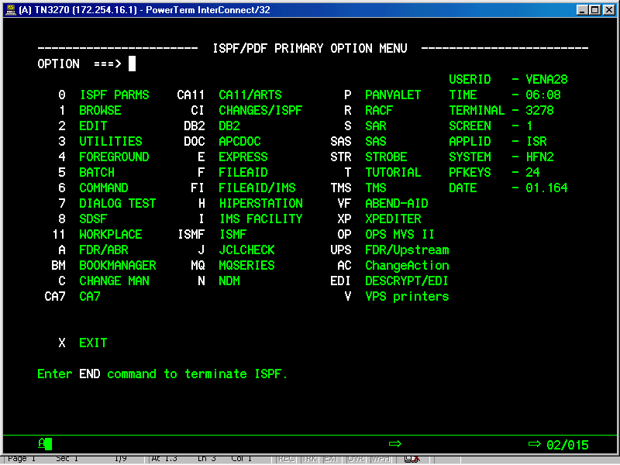
Type ‘XP’ on command line on ISPF menu, you will get following Xpediter Primary Menu

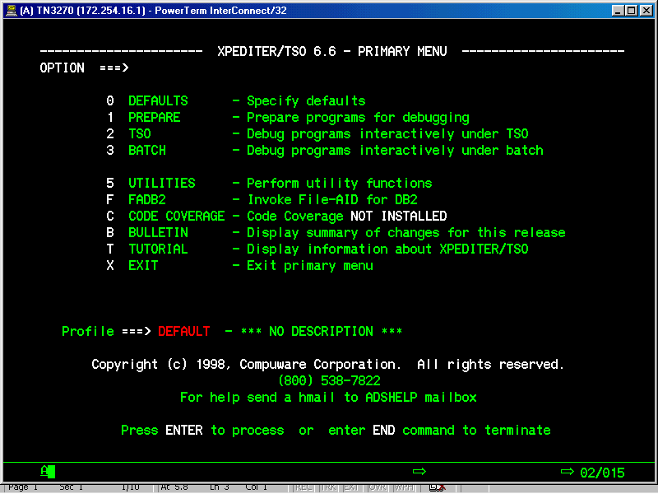

First you have to prepare your program to test in
Xpediter. Select 1 from Xpediter primary menu and will get
the following program preparation menu

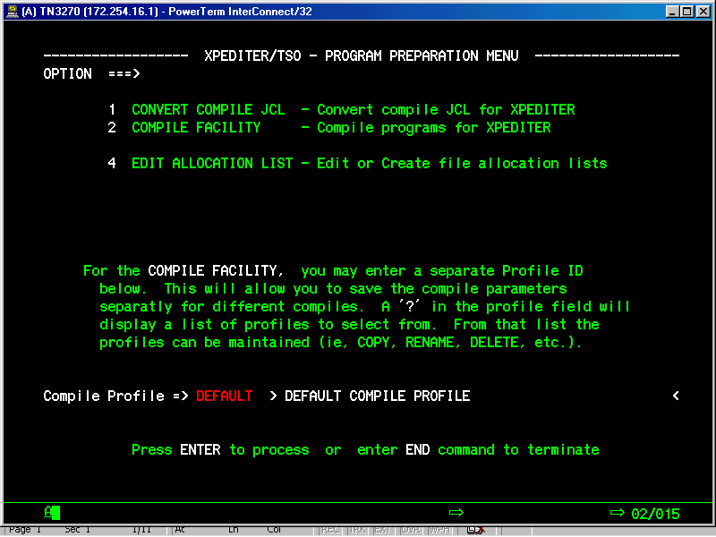

Select Option 4 from program preparation menu and will
get the following edit file list menu.

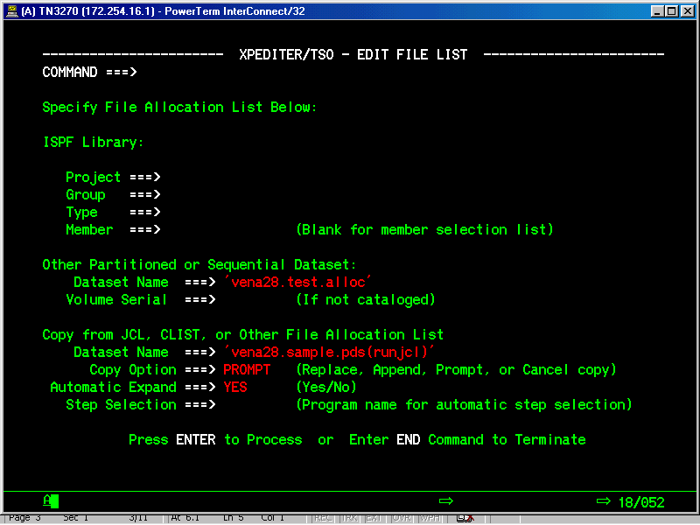

There are two dataset names you have to supply:
Other Partitioned or Sequential Dataset
Dataset Name ===> ( Mention the your own dataset )
Copy from JCL, CLIST, or Other File Allocation List
Dataset Name ===> ( Mention the JCL dataset name and member name of the Run JCL )
Press enter and u will get the following DDname menu

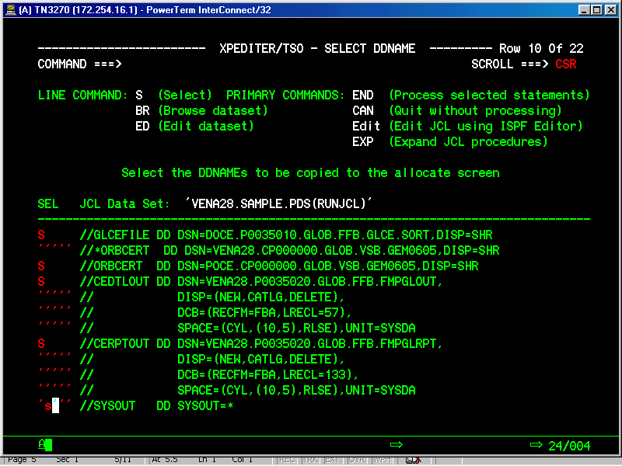

Select input, output DD names and sysout.

press F3 and will get the following edit file list menu.
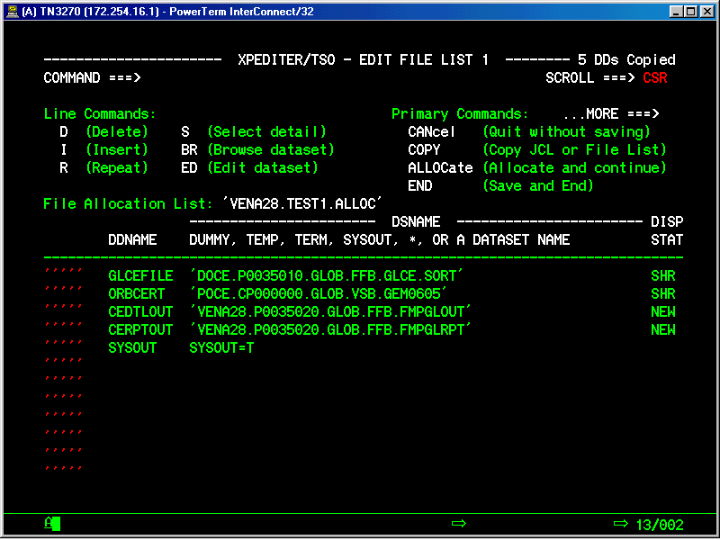

Type “ALLOC” on command line of the edit file list menu, press enter key. Then press F3 and press enter key again the allocated dataset will be saved.

This is end of the JCL Preparation for a particular program.

Select option-2(TSO) from Xpediter Primary menu, You will get the following standard menu.

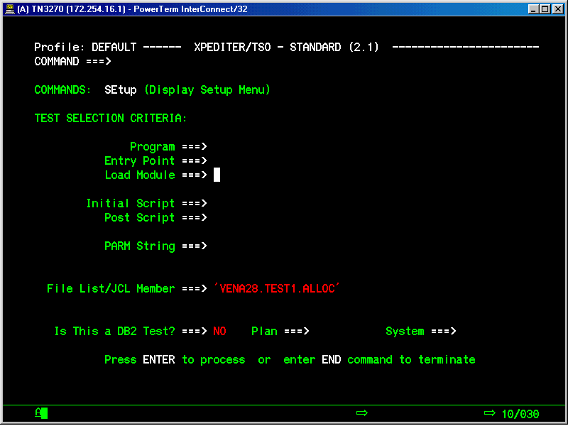

Type ‘SETUP’ on command line of the standard menu then enter. You will get the following setup menu.

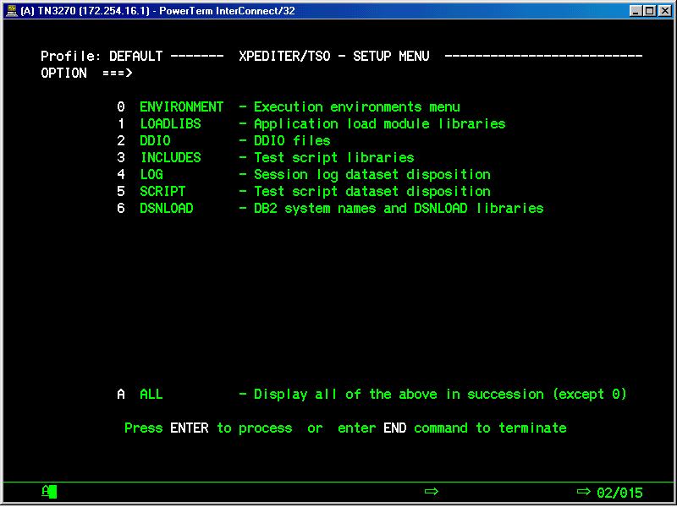

Select option 1 from setup menu and press enter key, You will get the following load module menu.

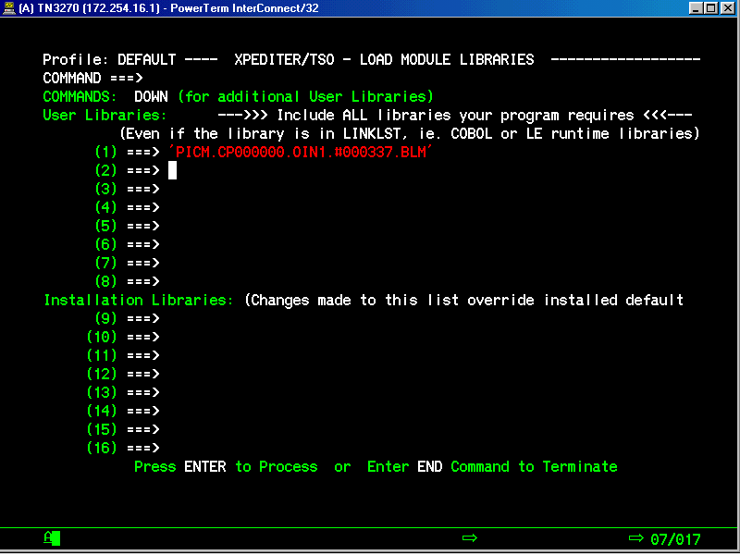

Give the load library dataset of the program.
press F3 and u will get the following setup menu again.

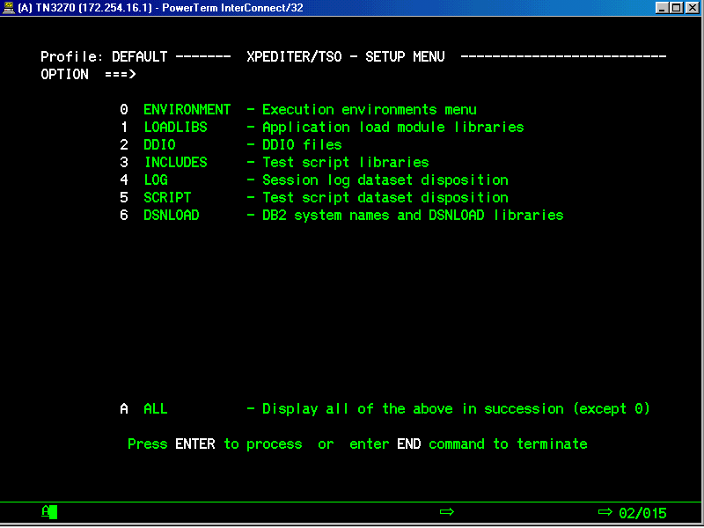

select option 2 from setup menu , press enter key will get the following DDIO files menu.

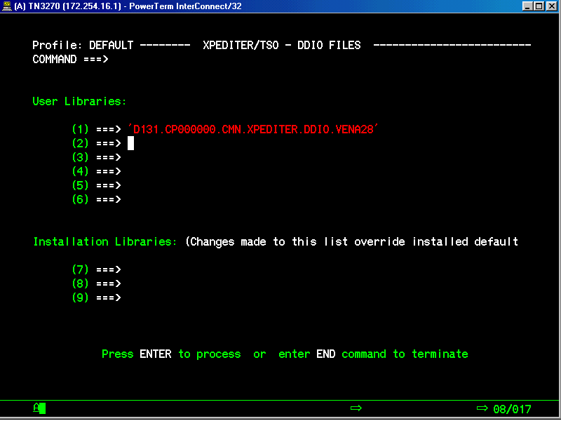

The primary input to XPEDITER/TSO is the following:

1. DDIO libraries containing the source listing members.

2. Load libraries containing the programs to be tested and
Debugged.

Note: The source listing dataset and your load libraries are
the output of the compile and link.

Include following steps in the compilation JCL, for getting the DDIO files,
Add these steps before link edit steps.

//XOPTIONS DD DISP=SHR,DSN=XT.XT64B1.XOPTIONS
//CWPDDIO DD DISP=SHR,DSN=FLGFGR1.COBOL.DDIO
//CWPPRMO DD *
COBOL(OUTPUT(PRINT,DDIO))
PROCESSOR(OUTPUT(NOPRINT,NODDIO),TEXT(NONE))
LANGUAGE(VSCOBOL)
DDIO(OUTPUT(NOLIST,NOXREF,FIND,NODMAP,NOOFFSET,COMPRESS))
//*

The above addition in JCL is needed only if you are not Using Changeman.If You are compiling in Change man, Compile with Xpediter option.

Press F3 twice. Will get the following standard menu.

For the Program, Entry point and Load module type program-name

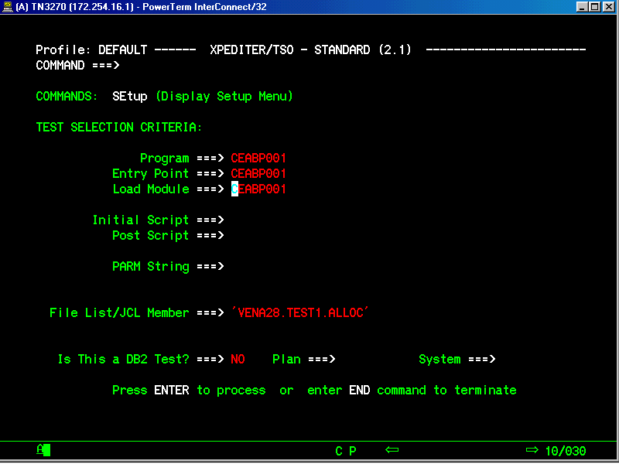

TESTING ONLINE PROGRAMS

After Entering CICS Region Type XPED XXXXXXXX(XXXXXXXX is the Program Name) and Press ENTER.

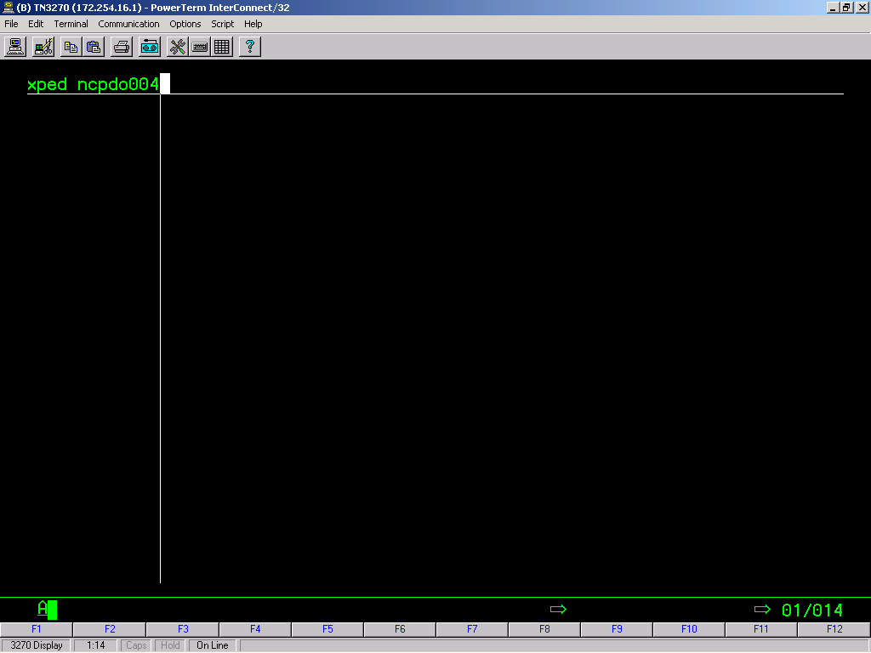

You will get the Following Screen.

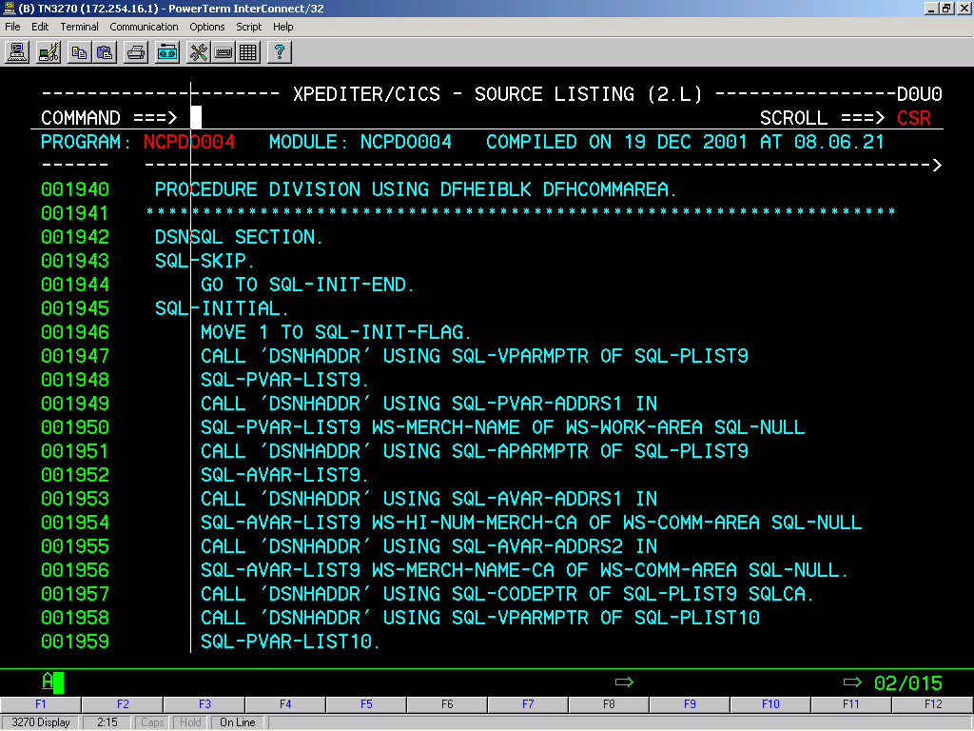

Type B at Command Prompt to Execute the Program from Beginning or Type B at the Line from which you want to Run.

It will give following Screen informing that Breakpoint was Set.

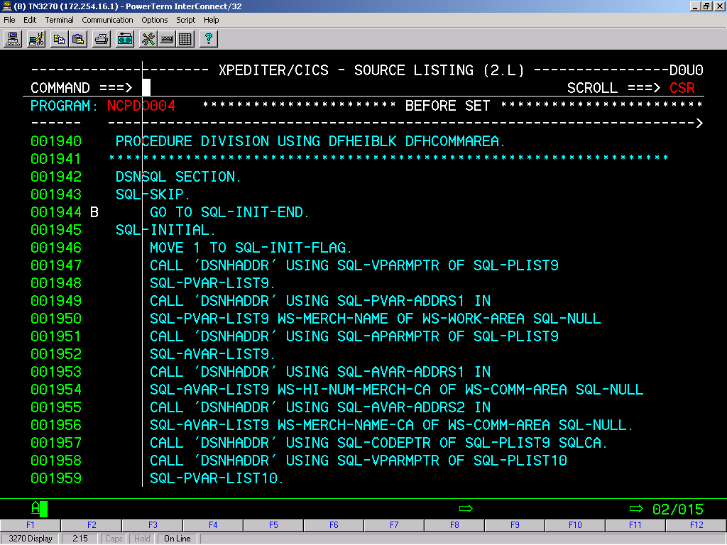

Press ESC Key, so that you will get Blank Screen. Type the Four Character Transaction-Id and Press ENTER. You will get the Following Screen.

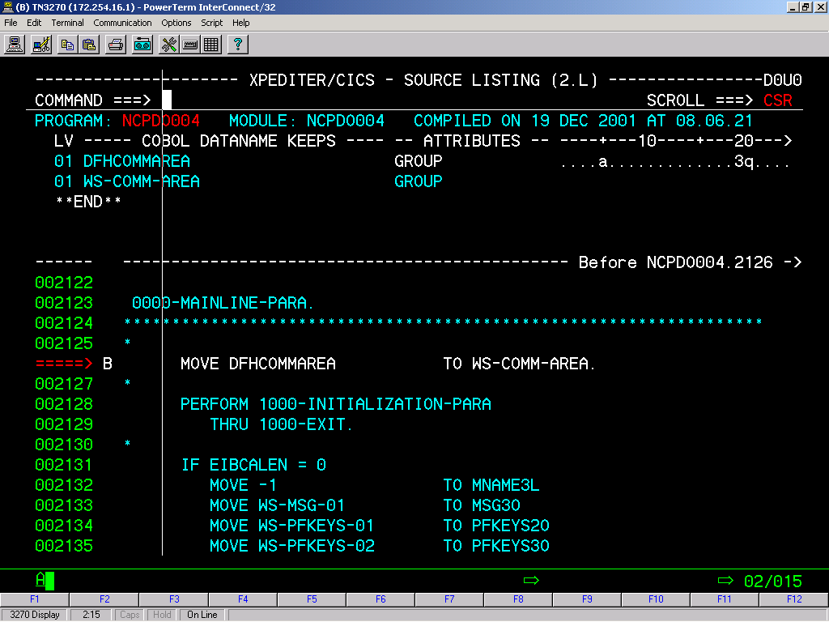

You can start executing the Program as same way as it was for Batch Program with help of PF9 and PF12 and other Keys..

PF KEYS

F1=HELP, F2=PEEK CSR, F3=END, F4=EXIT, F5=FIND, F6=LOCATE, F7=UP,
F8=DOWN, F9=GO 1, F10=LEFT, F11=RIGHT, F12=GO.

PF2 PEEK CSR : Displays the contents of the data name defined by the current cursor
position. The cursor must be in the Source window under a valid data
name.

PF6 LOCATE :Scrolls the source display to the current location where execution was
Suspended.
This command is useful when you want to check some logic in some other
Para than the current executing Para and want to return to the point where
the execution is positioned.
PF9 GO 1 :Executes the next logical instruction in your program, then pauses.

PF12 GO :Starts or resumes execution of your program

Log :To display log prior to termination

Go :To resume test execution or press Enter to resume test execution.

Break Points:

You can control program execution by using breakpoints. A breakpoint is a certain location in your program where you want program execution to stop.

Example.

000041 INIT-PARA.
000042 MOVE ZERO TO N-CNTR(1) N-CNTR(2) N-CNTR(3) N-CNTR(4).
000043 B OPEN INPUT INFILE.
000044 MOVE 'N' TO OUT-OF-RECS.

000045 ANALYZE-NEXT-REC.
000046 READ IN FILE INTO WORK-REC
000047 AT END
000048 MOVE 'Y' TO OUT-OF-RECS.

Note:
Press PF12 or type GO to execute program execution stops at 43 . If u want continue from the Break point, Press PF9 (GO 1) to execute the next statement.

Default Break Points:
- starts at the Procedure Division
- End with the Stop Run .

Deleting Break Points:

You can delete the Break Points by Typing D on the Line where Break Point was Set.
000041 INIT-PARA.
000042 MOVE ZERO TO N-CNTR(1) N-CNTR(2) N-CNTR(3) N-CNTR(4).
00D043 B OPEN INPUT INFILE.
000044 MOVE 'N' TO OUT-OF-RECS.
It will Delete the Break Point. You can Observe that “B” priorly set will go off after entering “D” and pressing ENTER.

Line commands.

- A and K
- P
- GT
- S

Enter an “A” line command on statement 46, setting an after
breakpoint at the READ statement. Next, type the “K2” line
command on statement 46 to display the contents of working
storage for WORK-REC (the second variable identified on line
46). See the example given. The K in column 9 of the window
indicates that it is an explicitly kept item and distinguishes
it from the automatically kept data.

000030 K 01 WORK-REC > ...
-
000028 01 OUT-OF-RECS > .
** END **
------ ----------------------------------------------
=====> MOVE 'N' TO OUT-OF-RECS.
000045 ANALYZE-NEXT-REC.
000046 A READ INFILE INTO WORK-REC
000047 AT END MOVE 'Y' TO OUT-OF-RECS.
. . . . . . . . . . . . . . . . . .

Note: You can delete the Variables kept using “K” by typing “D” .

00D030 K 01 WORK-REC > ...
-
000028 01 OUT-OF-RECS > .
** END **
------ ----------------------------------------------
=====> MOVE 'N' TO OUT-OF-RECS.
000045 ANALYZE-NEXT-REC.
000046 A READ INFILE INTO WORK-REC
000047 AT END MOVE 'Y' TO OUT-OF-RECS.
It will Delete the explicitly kept Variables.

P (Peek) line command, and press Enter. The screen automatically scrolls to the DATA DIVISION statement where the table is defined, inserts a P in column 9, and displays the occurrence and value of N-CNTR

Example:

10 N-NAME PIC X(21).

P 10 N-CNTR PIC 9 > 0000

01 OUT-OF-RECS PIC X.
01 TRIANGLE-TYPE PIC 9.
01 WORK-REC.

05 SIDE-A PIC 9(01).
05 SIDE-B PIC 9(01).
05 SIDE-C PIC 9(01).
B PROCEDURE DIVISION.
MAIN-PARA.
PERFORM INIT-PARA.
PERFORM ANALYZE-NEXT-REC
UNTIL OUT-OF-RECS = 'Y'.
PERFORM ENDING-PARA.

GT is used to resume execution at certain point or Starts Execution at certain Point . Type GT on the Line where you want to start execution and Press ENTER.

=====> MOVE 'N' TO OUT-OF-RECS.
00GT45 ANALYZE-NEXT-REC.
000046 READ INFILE INTO WORK-REC
000047 AT END MOVE 'Y' TO OUT-OF-RECS.

You can observe like this.

000044 MOVE 'N' TO OUT-OF-RECS.
=====> ANALYZE-NEXT-REC.
000046 READ INFILE INTO WORK-REC
000047 AT END MOVE 'Y' TO OUT-OF-RECS.

- S is Used to Skip the execution of a particular statement. For skipping a condition like ‘IF’ you have comment the entire block of condition.

=====> MOVE 'N' TO OUT-OF-RECS.
00S045 ANALYZE-NEXT-REC.
000046 READ INFILE INTO WORK-REC
000047 AT END MOVE 'Y' TO OUT-OF-RECS.

It will skip the execution of the line 45.
=====> MOVE 'N' TO OUT-OF-RECS.
00D045 S ANALYZE-NEXT-REC.
000046 READ INFILE INTO WORK-REC
000047 AT END MOVE 'Y' TO OUT-OF-RECS.

If you want to delete the skip you have to type ‘D’ and press ENTER. You can Observe that “S” priorly set will go off after entering “D” and pressing ENTER.

Command Line Commands:

- WHEN
- GOTO

1) WHEN is used to pause the execution of the program at certain point when the set condition arises even you are executing with PF12 Command.

COMMAND ===> WHEN WS-ITEM2 = 35000 SCROLL ===> CSR
------ -----------------------------------------------
000018 B PROCEDURE DIVISION.
000019 ******************************************************************
000020 0000-MAINLINE-PARA.
000021 ******************************************************************
000022
000023 CALL 'ROUTIN2' USING BY REFERENCE WS-ITEM1,WS-ITEM2.
000024 IF WS-CTR < 5
000025 MOVE 25000 TO WS-ITEM1
000026 MOVE 35000 TO WS-ITEM2

It will pause execution when the Value of WS-ITEM2 becomes 35000.You can continue the execution from this point onwards.

You can keep in the same way a variable name with out Value . Program execution pauses when ever the variable changes.

You can delete WHEN command by typing DELETE WHEN WS-ITEM2 = 35000 at the command line.

COMMAND ===> DELETE WHEN WS-ITEM2 = 35000 SCROLL ===> CSR
------ -----------------------------------------------
000018 B PROCEDURE DIVISION.
000019 ******************************************************************
000020 0000-MAINLINE-PARA.
000021 ******************************************************************

2) GOTO used to transfer the execution to particular line.

COMMAND ===> GOTO 000024 SCROLL ===> CSR
------ -----------------------------------------------
000018 B PROCEDURE DIVISION.
000019 ******************************************************************
000020 0000-MAINLINE-PARA.
000021 ******************************************************************
000022
000023 CALL 'ROUTIN2' USING BY REFERENCE WS-ITEM1,WS-ITEM2.
000024 IF WS-CTR < 5
000025 MOVE 25000 TO WS-ITEM1
MOVE 35000 TO WS-ITEM2

It will transfer Control of execution to 24th line. It is similar as line command GT.

